Locked Up and Locked Down
Segregation of Inmates with Mental Illness
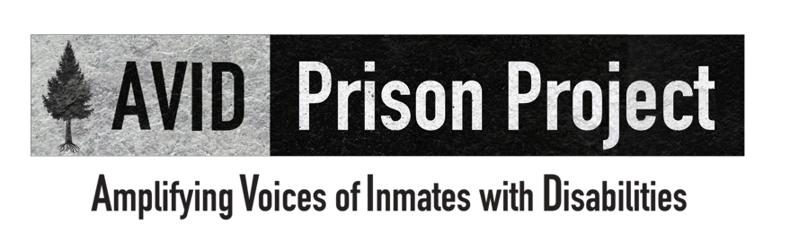
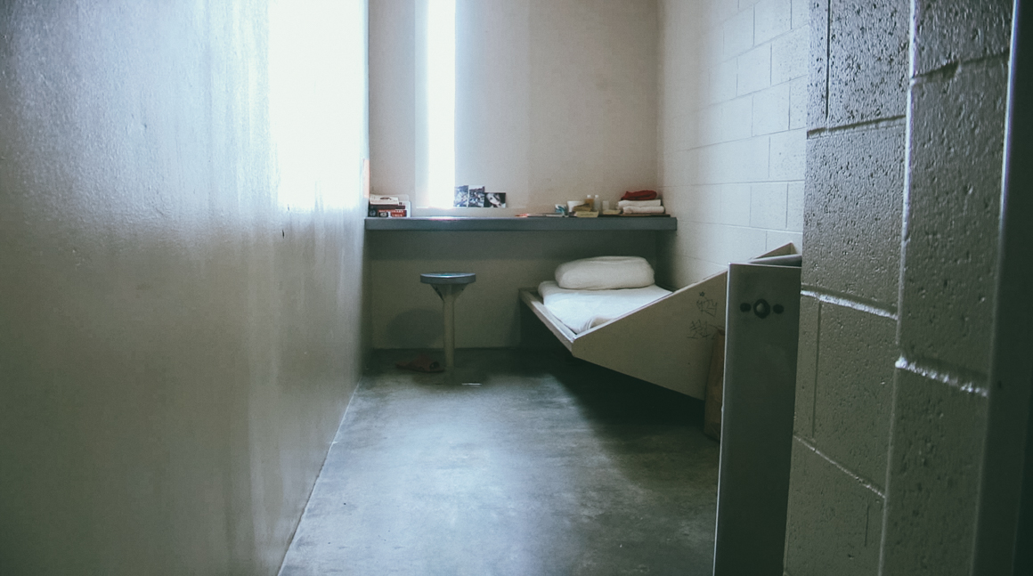

Locked Up and Locked Down
Segregation of Inmates with Mental Illness

By Anna Guy
Amplifying Voices of Inmates with Disabilities Prison Project
September 8, 2016

TABLE OF CONTENTS

I. EXECUTIVE SUMMARY 5
II. BACKGROUND 9
A. Overview of the P&A System 9
B. Methods of P&A Advocacy 10
1. Non-Litigation 10
a. Informal Advocacy Within a Prison 10
b. Systemic Advocacy with Corrections Officials 10
c. Coordination with Community Stakeholders and Policy Makers 11
2. Litigation 12
C. The Effect of Segregation on Inmates with Mental Illness 12
D. Laws Related to Segregation of Inmates with Mental Illness 15
III. PRISON ADVOCACY BY THE PROTECTION AND ADVOCACY SYSTEM 16
A. Non-Litigation 17
B. Litigation 24
IV. CONCLUSION 34
V. RECOMMENDATIONS 34
A. National Recommendations 34
B. State Recommendations 36
ABOUT THE PROJECT 38
ABOUT THE AUTHOR 38

For a multimedia version of this report featuring interviews of inmates, experts, and more, please visit: AVIDprisonproject.org.

EXECUTIVE SUMMARY
Our nation’s prison systems have been housing people in solitary confinement, or segregation, for decades. As inmate populations increased throughout the 1980s and 1990s, prisons turned to segregation, claiming it was a necessary intervention to curb institutional violence. As a result, between 80,000 to 100,000 inmates are currently placed in small single person cells for 22 to 24 hours per day, for days, if not months or years at a time. Notably, many of those housed in segregation found their way there due to behaviors associated with a mental illness, or they developed symptoms of mental illness due to their prolonged isolation. Many inmates with mental illness are not only locked up and serving a sentence, they are disproportionately locked down in segregation, where they remain isolated in their cells and experience severely restricted access to programs and activities, including mental health treatment.
Research suggests that segregation does not in fact decrease violence or make prisons safer. Moreover, experts have found that the crushing isolation of segregation has a debilitating effect on inmates, especially inmates with mental illness. Even the president of the United States has recognized that a person’s mental illness can worsen in segregation, and inmates with mental illness are more likely to commit suicide. In response to these findings, advocates have argued that the imposition of such restrictive conditions on inmates with mental illness violates the Eighth Amendment prohibition of cruel and unusual punishment as well as the Americans with Disabilities Act (ADA) and Section 504 of the Rehabilitation Act of 1973 (Rehab Act), and have fought for an overhaul of the use of segregation in the nation’s prison systems.
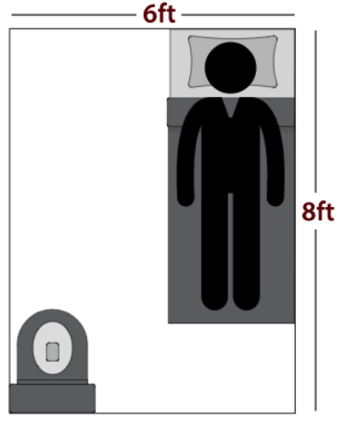
Very few outsiders are allowed into prisons, and the public rarely gets to witness the conditions in which many inmates are confined. In recent years, protection and advocacy agencies (P&As), organizations granted with the special federal authority to enter facilities that serve people with disabilities, have been going to the most segregated areas of prisons to identify issues facing people with disabilities. P&As have received countless reports of abuse and neglect of inmates in segregation, including prolonged isolation, deplorable conditions, inadequate care, increased self-harm and suicide attempts, and even death.
In recognition of the growing population of inmates with disabilities, in 2012, Disability Rights Washington, the P&A for Washington State, began focusing more attention on the state’s prisons, investigating the conditions of these correctional settings and working on creative solutions to some of the most serious problems faced by inmates with mental illness, brain injuries, and physical and intellectual disabilities. In early 2014, with increased funding through a private grant, Disability Rights Washington created Amplifying Voices of Inmates with Disabilities (AVID), a project with the sole purpose of protecting and advancing the rights of inmates with disabilities and assisting those who are reentering society. In September 2014, AVID brought together staff from the P&As in New York, South Carolina, Arizona, Colorado, Louisiana, and Texas, as well as from the National Disability Rights Network, to strategize about ways to increase national attention on the issues faced by inmates with disabilities.
Layout of a 6 ft. by 8 ft. cell.
This report, which has grown out of that collaborative national effort, examines issues related to the segregation of inmates with mental illness in our state prison systems, including the harmful effects of prolonged isolation on that population, the excessive use of force that often precedes or accompanies placement in segregation, and the restricted access to programs and services in segregation. P&As from across the country provided examples of either past or ongoing advocacy, demonstrating the crucial role that P&As have played in fighting against the excessive use of segregation of people with mental illness in our nation’s prisons. This advocacy is multi-modal, ranging from routine monitoring, to informal and individual advocacy, to systemic litigation.
This report begins with a brief overview of the P&A system, explains the different types of advocacy P&As use, describes the effect of segregation on people with mental illness, and outlines legal protections related to segregation of inmates with mental illness. Next, this report details the work P&As across the country have done to advance the rights of inmates with mental illness in segregation, dividing the advocacy into non-litigation and litigation strategies. Finally, the report concludes with a number of federal and state recommendations to build on the momentum gained by the P&As and their partners, including:
- Increased federal funding to the P&A network for corrections-based monitoring and advocacy;
- Creation of independent corrections ombuds offices at the state level in order to address inmate concerns before they rise to the level of litigation;
- Increased data collection by the U.S. Department of Justice’s Bureau of Justice Statistics regarding the prevalence of people with mental illness in U.S. prisons and jails;
- Increased monitoring and outreach in prisons by P&As across the country; and
- Fostering of collaborative relationships between state prison systems and P&As.

Ultimately, this report is a call to action and is meant to encourage partnerships among the P&A network, prison advocacy groups, and interested stakeholders to increase focus on what has become an international conversation on the use of segregation in America’s prisons.

VOICES FROM SEGREGATION
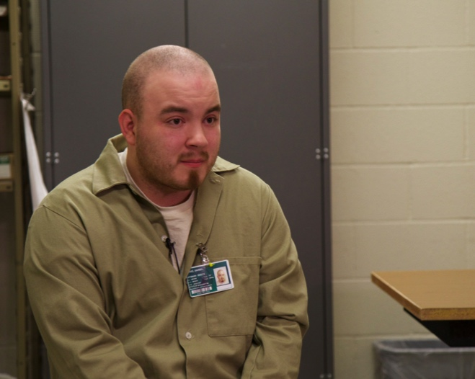
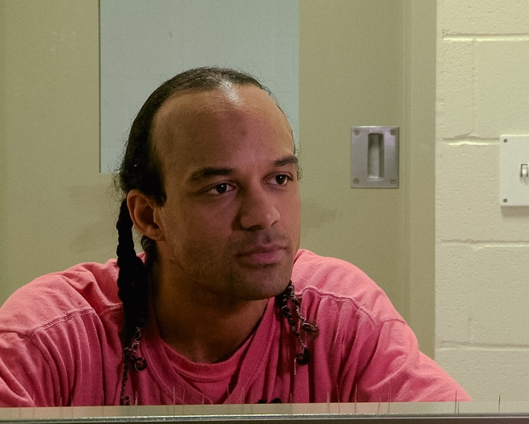

Daniel Perez, Washington
“Segregation, for me, was pretty much hell…”

Eldorado Brown, Washington
“They don’t understand that placing me in the hole exacerbates my mental illness to a whole different degree…”

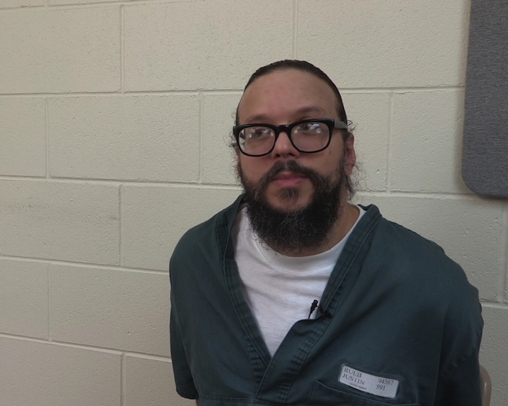
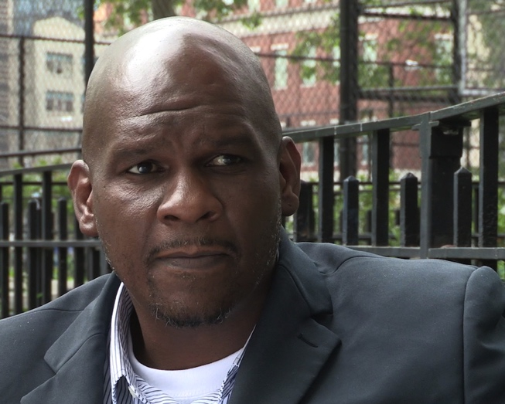

Justin Rueb, Colorado
“I really can’t deal with other people very well anymore…”
Five Mualimm-ak, New York
“It’s a different lens living in a world of punishment.”

BACKGROUND

Overview of the P&A System
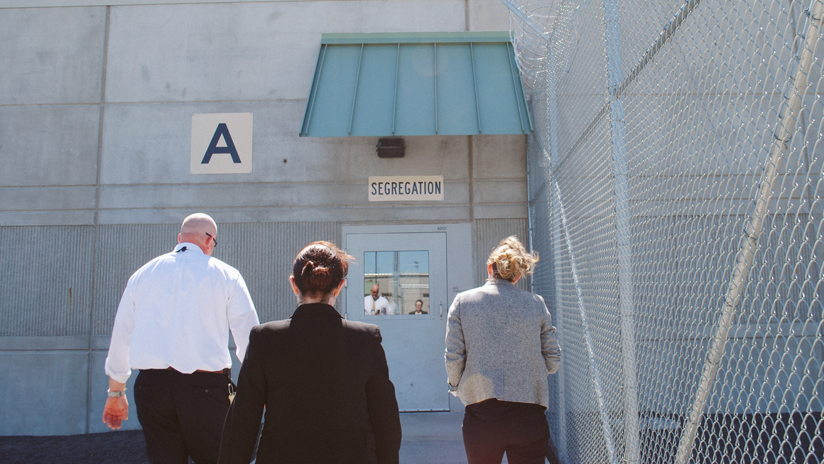
The P&A system was created in the 1970s after a series of news reports exposed the horrific institutional conditions in which people with developmental disabilities were housed. This news coverage prompted federal legislation to create a national network of P&As to advocate on behalf of people with developmental disabilities. Since that time, additional legislation has been passed, expanding the scope of P&As to include advocacy on behalf of all people with disabilities, in any setting, from the community to prison. This legislation also grants P&As the authority to monitor settings in which people with disabilities live, work, or receive services, as well as the power to investigate allegations of abuse and neglect of people with disabilities. This unique authority allows P&As to monitor and investigate in even the most segregated settings, and gives P&As access to individuals and records as they seek to enforce and defend the rights of people with disabilities. As increasing numbers of people with disabilities have become incarcerated, the P&A network has used its access authority to conduct monitoring and advocacy in the nation’s prisons.
AVID Prison Project attorneys walk toward the entrance of a segregation unit.

Methods of P&A Advocacy
In challenging the segregation of inmates with mental illness, there are numerous methods of advocacy that may be employed by the P&A network. Given the statutory requirements in many of the authorizing statutes for P&As, agencies generally begin with the lowest level of intervention required, employing higher levels of advocacy as needed. This advocacy may range from information and assistance to individual inmates, to systemic monitoring or large scale litigation. For the purposes of this report, these levels of advocacy, described below, are separated into two categories: non-litigation and litigation.

Non-Litigation
Non-litigation advocacy encompasses informal advocacy within a prison, systemic advocacy with corrections officials, and coordination with community stakeholders and policy makers. These advocacy strategies are described briefly below.

Informal Advocacy Within a Prison
P&As routinely provide information and assistance to inmates with mental illness over the phone or by letter. By providing prison policies, complaint forms, resources, and practical suggestions, P&As assist inmates with mental illness in navigating the prison system to access appropriate programs and services, and support them in becoming effective self-advocates. This service also allows P&As to monitor common issues occurring in the prisons, and identify any potential systemic concerns as they arise.
P&As also undertake individual representation of inmates in segregation, often beginning any such case by advocating with prison mental health staff and following through with prison administrative staff. Through working with staff within the prison, P&As have been able to secure less restrictive conditions for inmates.

Systemic Advocacy with Corrections Officials
P&As may also develop relationships with officials within a state’s department of corrections. Through meeting and sharing information with prison administrations at both individual facilities and headquarters, prisons are able to take proactive steps to address issues P&As identify. P&As also often use their federal authority to monitor the conditions in prison, meeting with inmates in segregation during such visits to discuss their concerns regarding conditions in segregation and access to mental health care in those units. When P&As raise issues to prison officials that are identified during these monitoring visits, prisons are able to resolve many problems and avoid litigation.

Coordination with Community Stakeholders and Policy Makers
P&As have also worked to create and expand the network of advocates and community stakeholders dedicated to prison-related issues. Through working with families and friends of inmates with disabilities, as well as other community organizations, P&As have built coalitions to advocate within the prison administration as well as with state and local government officials on behalf of inmates with mental illness. This work has ranged from providing training on disability-related issues to community groups and governmental agencies, to participating in workgroups and taskforces related to criminal justice and prison issues.
Similarly, P&As have worked to educate policy makers about prison-related issues, including commenting on proposed state legislation regarding prison programs, and offering information and insight related to policy and legislative reform efforts aimed at protecting the rights of inmates with mental illness in prison.

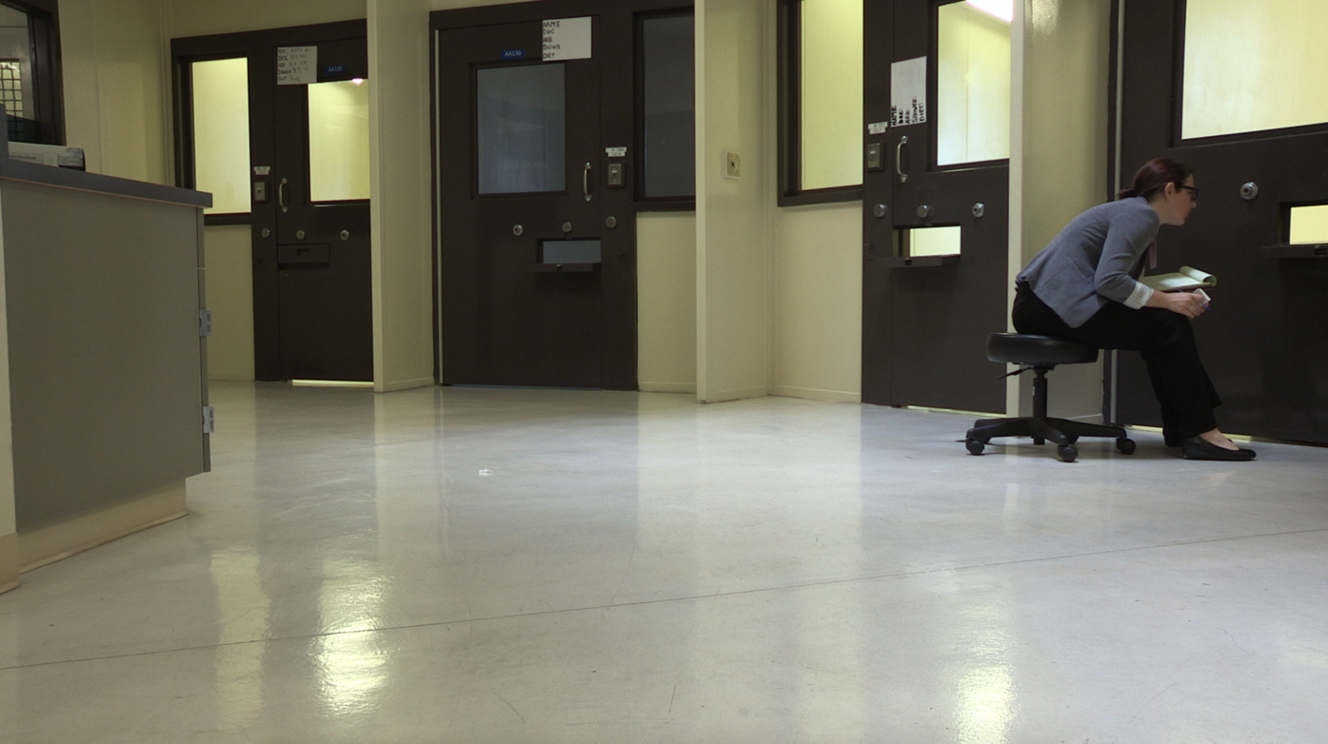
AVID Prison Project attorney, Anna Guy, speaks with an inmate in segregation through a cuff port.

Litigation
When litigation has been required, P&As have raised claims based on the Eighth and Fourteenth Amendments of the U.S. Constitution as well as the ADA and the Rehab Act. While P&As have engaged in litigation in both state and federal courts on behalf of individual inmates, these cases are most often brought as class actions. In the last decade P&As have increasingly served as organizational plaintiffs in such cases, representing the interests of their constituents in challenging systemic conditions and practices that impact inmates with disabilities.
Overall, this powerful range of advocacy tools makes the P&A network uniquely positioned to achieve a broad range of positive individual and systemic outcomes for people with mental illness in prisons and can attract partnerships with other advocacy groups and law firms to combine resources and expertise to reach common goals on behalf of the network’s constituents.

The Effect of Segregation on Inmates with Mental Illness
Segregation is generally recognized as the isolated confinement of an inmate for 22 to 24 hours a day in a small cell, typically about six by eight feet, containing only a bed, a sink, and a toilet, and enclosed by a metal door with a small window and cuff port. While inmates may be placed in segregation for a number of reasons, segregation can last for days, months, years, and even decades, regardless of its purpose.
Designed to disconnect inmates from most forms of human contact and environmental stimulation, inmates in segregation have little access to programming, services, or treatment during the course of their confinement. For inmates with mental illness, these conditions are devastating as contact with mental health clinicians typically consists of brief assessments conducted at cell-front. Mental health interventions such as therapy and structured activities are not usually available in these settings, and prison rules commonly preclude segregated inmates from leaving their cells; thus, the only mental health treatment for inmates in segregation is often psychotropic medication. Furthermore, meaningful interaction with staff and the outside world is also restricted; food and other items are usually passed through a slot in the cell’s steel door, and visitation and telephone communication may be limited or banned altogether. Access to fresh air and sunlight is also limited; recreation time is spent in a cage-like enclosure up to one hour per day, three to five times a week. Moreover, lights in segregation are often illuminated 24 hours per day.
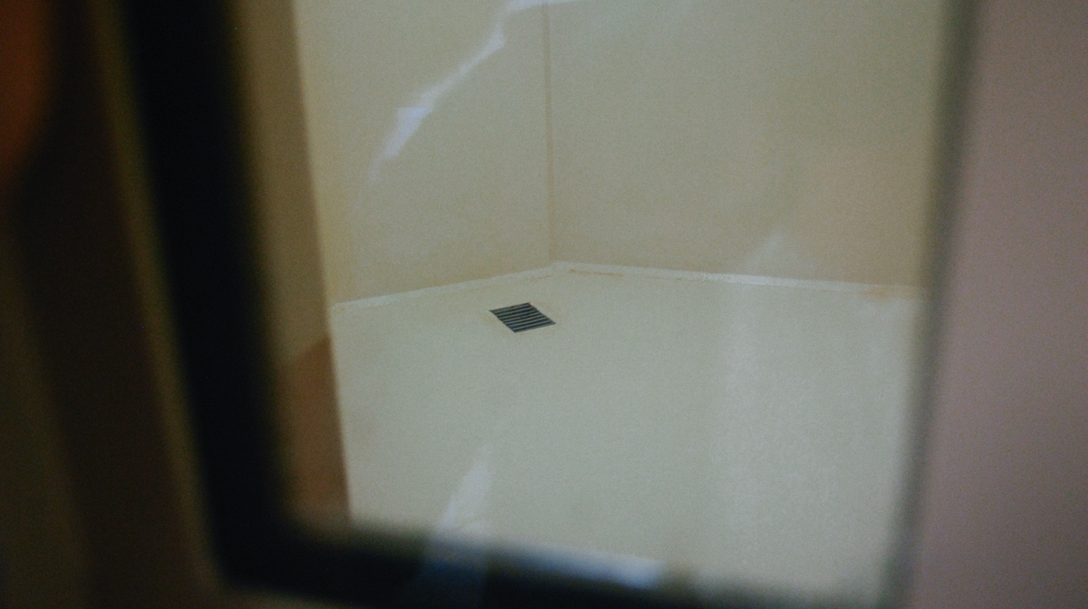
A “rubber room” used as an isolation cell for inmates at risk of self-harm. The cell has a grate in the floor where inmates relieve themselves.

Research reveals that inmates placed in these harsh conditions often experience intense mental and physical distress; for inmates with mental illness, these conditions can have a catastrophic impact. Inmates in segregation routinely report extreme sensory deprivation, sleep deprivation, psychiatric decompensation, hallucinations, and behaviors relating to self-harm and even suicide. Because prison staff that work on these units often have little to no training related to working with inmates with mental illness, reports have found it is not unusual for prisons to employ chemical agents such as pepper spray or physical restraints to curtail or control the behaviors of inmates with mental illness in segregation.
In addition to these harsh conditions, inmates in segregation do not have access to the same programs and activities available to inmates in other, less restricted, areas of the prison. Many systems require that inmates in solitary confinement be escorted in restraints by two or more officers. This and other security restrictions often result in limited access to programs such as skill building, education, vocational training, group therapy, socialization, or other activities. These activities are important tools for helping inmates learn skills for daily living and medication compliance, including how to take care of their most basic personal hygiene and everyday needs. Thus, limiting access to programs hinders the ability of inmates to live and cope with the symptoms of their mental illnesses over time.
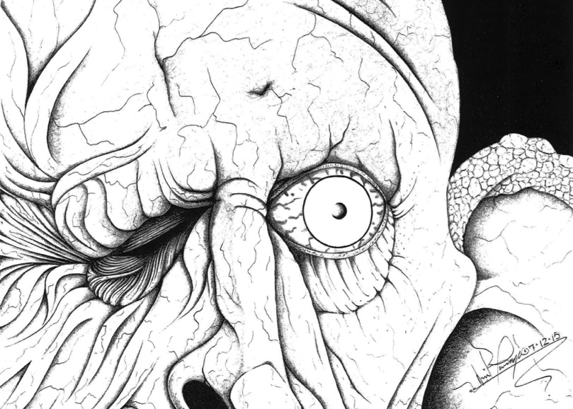
Moreover, when the symptoms of a segregated inmate’s mental illness escalate, the inmate may be sent to suicide watch, an even more restrictive form of segregation. While many inmates are transferred to suicide watch from another segregated setting after inflicting self-harm or attempting suicide, rather than receive therapeutic services necessary to alleviate symptoms of mental illness, inmates on suicide watch are placed under even more extreme conditions of segregation. Here, inmates are watched 24 hours a day and are generally stripped of their personal belongings, clothed in a suicide smock, and forced to urinate and defecate through a grate in the floor.
A black and white drawing of a wrinkled face with one eye, by inmate David Troupe.
In the aggregate, while segregation is difficult for all inmates, it is particularly difficult for inmates with mental illness. While these inmates often have unique needs for specialized housing, programming, and treatment, such services are generally not available or provided. Furthermore, inmates with mental illness are often placed in the most restrictive forms of segregated housing where they receive even less mental health care and are treated more harshly than other inmates in segregation. As a result, inmates with mental illness in segregation are often subject to the most extreme conditions of confinement.

Laws Related to Segregation of Inmates with Mental Illness
In recent years, inmates and advocates have brought lawsuits challenging these excessively harsh conditions and limited access to treatment and programs, alleging that segregation violates the Eighth Amendment prohibition of “cruel and unusual punishments,” particularly with respect to inmates with mental illness. While the U.S. Supreme Court has held that this Eighth Amendment prohibition applies in segregation cases, inmates must prove that prison staff acted with “deliberate indifference to a substantial risk of serious harm to a prisoner” to demonstrate an Eighth Amendment violation. Courts have found that this “deliberate indifference” standard is equivalent to “recklessly disregarding that risk.” Mere negligence is not sufficient to demonstrate deliberate indifference.
An Eighth Amendment challenge alleging deliberate indifference must satisfy both a subjective and objective test. Under this two pronged test, the prison official must be shown to be subjectively indifferent, in that he “disregards a risk of harm of which he is aware.” Whether the prison official had knowledge of the risk can be demonstrated “in the usual ways, including inference from circumstantial evidence, … and a factfinder may conclude that a prison official knew of a substantial risk from the very fact that the risk was obvious.” The second prong, the objective test, requires that the inmate show that the prison official’s acts violated “contemporary standards of decency.” Such objective indifference can be manifested by prison officials in a number of ways, including intentionally delaying or denying an inmate’s access to medical care, including mental health care, interfering with prescribed treatment, or in the systemic delivery of medical care.
Various courts have applied the two-prong deliberate indifference test to segregation claims brought by inmates with mental illness and found that segregation of this population violates the constitutional prohibition of cruel and unusual punishment. For instance, in Madrid v. Gomez, a California district court found that housing inmates with mental illness and inmates “at a particularly high risk” of experiencing mental illness in segregation violated the Eighth Amendment. However, the court also held that conditions in segregation did not violate the Eighth Amendment for those inmates with “normal resilience.” In Ruiz v. Johnson, a Texas district court went further and held that the conditions of Texas’ administrative segregation units violated the Eighth Amendment “through extreme deprivations which cause profound and obvious psychological pain and suffering.” With respect to inmates with mental illness, the court further reasoned that “the severe and psychologically harmful deprivations of [the] administrative segregation units are, by our evolving and maturing society’s standards of humanity and decency, found to be cruel and unusual punishment.” The court in Jones’ El v. Berge took the extraordinary step of removing inmates with mental illness from a super-max prison after finding the mental health screening and monitoring tools grossly inadequate and ineffective, holding deliberate indifference existed because the tools “serve as little more than band-aids to the potentially detrimental conditions to which defendants are subjecting mentally ill inmates.”
Along with the Eighth Amendment, advocates have argued that Title II of the ADA and Section 504 of the Rehab Act preclude prisons from discriminating against inmates with mental illness. While the ADA protects inmates in state-run prisons, the Rehab Act applies to prisons that receive federal funding. Together, these statutes provide non-constitutional causes of action to challenge placement in segregation on the basis of mental illness, prolonged stays in segregation due to symptoms of mental illness, and the limitation and denial of access to services and programs to inmates in segregation with mental illness.

PRISON ADVOCACY BY THE PROTECTION AND ADVOCACY SYSTEM
As described below, P&As and their partners have successfully advocated to limit or end the segregation of inmates with mental illness in various state and federal systems, employing advocacy methods ranging from basic information and assistance to individual inmates to large-scale systemic litigation. These examples, separated into non-litigation and litigation, demonstrate the critical role P&As have played in providing independent external monitoring and advocacy in our nation’s prisons while also making clear that much still needs to be done to advance and protect the rights of inmates with mental illness in segregation.

Non-Litigation
- In 2014, Disability Law Colorado, the Colorado P&A, teamed up with the American Civil Liberties Union (ACLU) of Colorado to investigate the mental health treatment and isolation of inmates in administrative segregation as well as the conditions in the residential treatment programs for inmates with mental illness within the Colorado prison system. Disability Law Colorado’s concerns included the prolonged segregation of inmates with serious mental illness; the failure to provide adequate mental health care and medication management; the failure to maintain adequate numbers of appropriately trained mental health, clinical, and correctional staff; and the failure to provide meaningful out-of-cell time for recreation, therapy, and socialization. Soon after the investigation began, the prison made policy changes that instituted a minimum of 10 hours of out-of-cell therapeutic and 10 hours of out-of-cell non-therapeutic recreation per week, depending on an inmate’s custody level. Monitoring and investigation are ongoing to ensure compliance with the policy changes.
- In 2015, to address concerns that inmates in segregation were routinely denied access to mental health services, including medication, Connecticut Office of Protection and Advocacy for Persons with Disabilities met with the Commissioner of the Department of Corrections and various other prison personnel, including clinical staff, to discuss inmate access to mental health treatment at the State’s supermax facility. After meeting, it was agreed that inmates with mental illness and a P&A advocate would participate in treatment decisions with prison clinical staff.
- In 2015, Disability Rights Iowa selected one men’s facility and one women’s facility to investigate the use of segregation of inmates with mental illness as a punishment for violations of institutional rules, including the number of occurrences, duration of segregation, and consideration of mental illness in disciplinary proceedings. The Department of Corrections has been supportive of the effort, has allowed the P&A an unprecedented level of access to complete its investigation, and has requested recommendations on how to improve the Department’s policies concerning segregation of inmates with mental illness. In the past, Disability Rights Iowa successfully worked with the Department to improve its restraint policies and its training about inmates with mental illness for correctional officers.
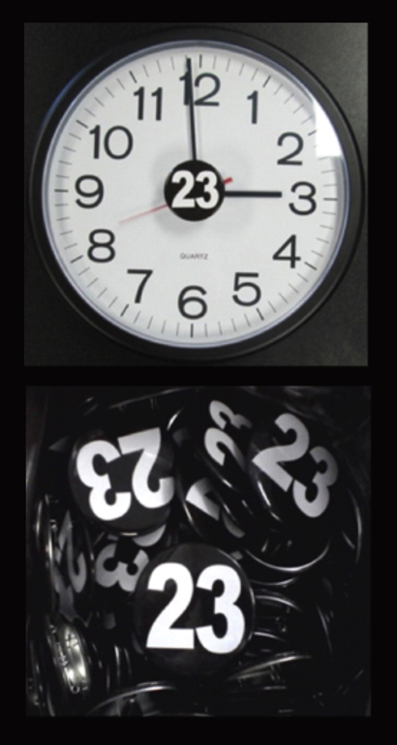
- Kentucky Protection and Advocacy made it an organizational priority to investigate reports of abuse or neglect and deaths of inmates with mental illness in segregation in 2016. To carry out this priority, the P&A plans to complete monitoring in all 14 state prisons before the end of September 2016 and has opened several individual cases involving prison inmates with serious mental illness over the last year.
Kentucky Protection and Advocacy also requested records and compiled data about the mental health treatment available to inmates in state prisons, including the reasons for placement in segregation and the length of time inmates remain in segregation. Following the P&A’s records requests, the Department of Corrections implemented a new data tracking and classification system to document the number of inmates with serious mental illness, intellectual disabilities, and brain injuries in prisons throughout Kentucky.
The P&A has also provided public comments to the Department of Corrections on amendments to policies and procedures, including policies regarding special management inmates (inmates who spend 23 hours per day in a cell) and mental health services. In light of the P&A’s comments, the Department decreased the duration of inmates’ initial administrative segregation stay from a maximum of 60 days to a maximum of 30 days. The Department also secured an expert for consultation on further segregation reform. The P&A has also reviewed four incidents of alleged inappropriate restraint. When a review of the Department’s secure restraint policies is complete, the P&A will provide additional comments to ensure inmates with mental illness are not being inappropriately restrained. The P&A will continue to monitor and review amendments to Department regulations, policies, and procedures that impact inmates with mental illness into the next legislative session.
A clock with a 23-hour awareness button in the center of the dial, above a photo of a pile of 23-hour awareness buttons.
Kentucky Protection and Advocacy also advocates for the approximately 300 inmates with serious mental illness in segregation statewide by handing out awareness buttons. The button with the number 23 signifies the number of hours per day that inmates with mental illness spend in their cell. On the 23rd day of each month, the P&A posts disability-related criminal justice reform information on its Facebook page and P&A staff wear the buttons.
- In 2014, to explore the criminalization of mental illness and the impact of segregation on mental health, Disability Rights Nebraska released a report highlighting the psychological and physical harms of segregation on inmates with mental illness, and shared its findings with the Nebraska Department of Corrections and state senators. The findings included: a connection among segregation, serious mental illness, and self-harm and suicide attempts; limited access to mental health treatment and programs in segregation and an underfunded mental health services budget for inmates in segregation; unique barriers to reentry for inmates with mental illness; and the need for systemic community mental health reform.
As a result, legislation was proposed and the P&A was consulted to provide language related to issues raised and recommendations made in its report, which included data collection on the use of segregation, developing a long-term plan to decrease the use of segregated housing, and implementing Department rules and regulations to ensure that inmates in segregation are housed under the least restrictive conditions. Disability Rights Nebraska supported these bills throughout the legislative process, and in the following session legislation was passed to limit the use of segregation and improve the treatment of inmates with mental illness. A special investigative committee was also formed to further examine prison issues, specifically inmates with mental illness and segregation. Disability Rights Nebraska has continued to educate state legislators about the need for segregation reform and participates in a workgroup with state corrections stakeholders aimed at reducing the use of segregation in Nebraska prisons. The P&A has also convened its own multi-disciplinary workgroup focused on achieving systemic improvements for inmates with mental illness. The committee and workgroups are ongoing.
- In 2000, a coalition including Disability Advocates, Inc., began actively pursuing a legislative solution to the problems facing inmates with mental illness in segregation in response to New York’s increased use of cell confinement sanctions and building of segregation units called Special Housing Units (SHUs). After three years of this pursuit, legislation was introduced to provide treatment to inmates with mental illness and limit the use of SHUs. Disability Advocates, Inc. remained active in this legislative advocacy until it instead focused its efforts on a lawsuit (discussed in the Litigation section of this report) against the Department of Corrections and Community Supervision, the state Office of Mental Health responsible for providing mental health services in the prison system, as well as individual superintendents and Mental Health officials to address the deliberate indifference to inmates with serious mental health needs by failing to provide adequate mental health services and imposing punishments that exacerbate mental illness. Meanwhile, the coalition continued its legislative work, but the bill was vetoed.
However, in 2007, after a litigation settlement was reached, a bill passed that incorporated and improved upon the litigation settlement’s terms. With some exceptions, treatment for inmates with mental illness carrying SHU sanctions increased to four rather than two hours of out-of-cell treatment and was to take place in residential mental health treatment programs. In addition, the bill contained a presumption against added SHU sanctions for inmates in the residential mental health treatment programs. What is now known as the “SHU Exclusion Law” went into effect in 2011 following the sunset of the lawsuit’s settlement agreement.
Since the law’s passage, Disability Rights New York testified against a proposed delay in the bill’s effective date, and twice testified by invitation before the joint Assembly and Senate hearings on mental health treatment in the state prison system. The P&A also testified in favor of expanding the law’s exclusionary criteria to reach all inmates with mental illness. Disability Rights New York continues to monitor segregation in state prisons and investigate allegations of abuse and neglect of prisoners with mental illness in segregation.
- Disability Rights North Carolina conducted an investigation into the segregation practices of the North Carolina Department of Corrections after learning about two inmate deaths from public reports in 2011 and 2014. The P&A’s subsequent investigation revealed serious harm resulting from segregation as well as inadequate care and treatment for inmates with mental illness. In response, Disability Rights North Carolina employed a multitude of advocacy strategies to advance the rights of inmates with mental illness in segregation, including: monitoring prisons with a Centers for Medicare and Medicaid Services psychiatric nurse surveyor; conducting abuse investigations; issuing reports; making public recommendations; forming coalitions with other advocacy groups and prison leadership; and participating in forums to increase public awareness about the need for segregation reform. As a result of this advocacy, a national expert has twice provided consultation regarding the treatment of inmates with mental illness in segregation, prison Crisis Intervention Team training was initiated, and treatment chairs and tables were installed to facilitate out-of-cell treatment. In 2016, the Legislature provided funding to develop eight Therapeutic Diversion Units for inmates on control status with mental illness, and prison policies were updated to require prompt mental health screening of segregated inmates and limit the segregation of inmates with mental illness to no more than 30 days per year.
- After an inmate with mental illness died of dehydration in segregation, Disability Rights North Carolina conducted an investigation and issued a report with recommendations. In response, the North Carolina Department of Corrections convened a taskforce on mental health in prison. Disability Rights North Carolina and other advocacy groups provided input to the task force, which resulted in a 2015 report with 90 far-reaching recommendations, including improved and more frequent screening for disabilities, elimination of segregation for inmates under 21 years of age, out-of-cell treatment for inmates with a mental health designation, suicide prevention training, and clinical input in the disciplinary process.
- In March 2015, Disability Rights North Carolina conducted monitoring of the prison confining inmates under 18 years of age. The P&A discovered that as much as 38% of the youth were in segregated confinement under the same terms and conditions as segregated adults. Disability Rights North Carolina issued a report to the Director of Prisons, and continued monitoring and advocating for the elimination of segregation for youth. In June 2016, a new Youthful Offender Program was announced that eliminates the use of solitary confinement for inmates under age 18 and requires enhanced education services, behavioral health treatment, life skills development, and family and community reunification services.
- Since 2012, Disability Rights North Carolina’s monitoring and advocacy has resulted in concrete improvements to the conditions of confinement for inmates with disabilities, including: removal of thick metal-mesh screens from cell door windows in segregation blocks; issuing mattresses to every inmate placed in a suicide watch cell and upon admission to the acute mental health service unit; issuing a suicide smock and blanket instead of one or the other; and enforcing the out-of-cell exercise policy.
- Disability Rights Ohio began receiving an above average number of complaints from Ohio’s maximum security prisons, where most of the inmates are placed in segregation for extended periods of time. The first complaints were from inmates placed on suicide watch or crisis watch. They indicated that segregation was making their mental health symptoms worse and the prisons were offering little to no effective mental health care to address them. Some inmates even reported that prison officers were encouraging them to go ahead with their suicidal ideations, or chiding them not to commit suicide during their shift so they could avoid the paperwork. Throughout late 2015, the P&A investigated further by visiting three Ohio prisons with the largest populations in segregation. The P&A took pictures of the cells, recreation cages, and other areas used by inmates, and went cell-to-cell in selected units, speaking to over 110 individuals in segregation, over 75 of whom had a documented mental illness. These conversations revealed a number of other problems that resulted in further advocacy and follow up, including claims of excessive use of force, inadequate medical care, retaliation, and prolonged periods of 24-hour confinement. Finally, the P&A recorded extended interviews of 22 individuals who wanted to share their story with the public. Disability Rights Ohio then teamed up with the ACLU of Ohio to publish a public report in May 2016, Shining a Light on Solitary Confinement: Why Ohio Needs Reform. The report detailed findings from the investigation, outlined research into the problems of long-term solitary confinement, and listed specific reforms for the Department of Rehabilitation and Corrections to drastically reduce its use of solitary confinement and provide more rehabilitation, programming, and out-of-cell time to every inmate in segregation. The P&A and the ACLU of Ohio held a joint press conference and multiple interviews to publicize the report on Ohio television and radio programs. The Department of Rehabilitation and Corrections has stated that they will work to reduce solitary confinement, particularly for individuals with mental illness, and that new reforms will be announced in late 2016.
- Disability Rights Oregon conducted an investigation into the Oregon State Penitentiary’s Behavioral Health Unit (BHU), an intensive behavioral management and skills training unit for inmates with serious mental illness who have committed violent acts or disruptive behavior. Disability Rights Oregon released an investigation report, which concluded that inmates in the BHU were routinely isolated in their cells for 23 hours a day without timely access to mental health care and that mental-health related behaviors were often dealt with using force. While the Oregon Department of Corrections did not agree with all of the findings and conclusions in the P&A’s report, the Department agreed to improve treatment in the BHU and conducted a comprehensive review of the BHU that included consultation with a nationally-recognized expert. Following that review, the prison and the P&A entered into a Memorandum of Understanding that reflects the parties’ commitment to changes that include: allowing BHU inmates an average of 20 hours per week out-of-cell time, including 10 structured programing hours and 10 unstructured hours; enhanced access to mental health services with greater consideration of individual treatment needs; quarterly reports to the P&A for four years; and to pay for ongoing guidance from the expert. The required improvements will involve architectural, operational, and staffing changes. Following a joint funding request by the P&A and the Department, the Oregon Legislature allocated more than 8 million dollars that will be used by the Department to comply with the terms of the Memorandum of Understanding.
- Disability Rights Tennessee received a report in June 2015 that an inmate with mental illness was denied medical treatment by prison staff. Upon investigation, the P&A learned that the inmate requested pain medication after an assault and engaged in self-harm when the medication was denied. As a result of the self-harm behavior, the inmate was moved to a mental health segregation unit where he continued to self-harm, was placed on 24-hour watch, and was ultimately put in six-point restraints. The P&A’s investigation further revealed that the inmate remained restrained and in segregation for three months, during which time a feeding tube, and intravenous fluids and medications were required. Disability Rights Tennessee initiated discussions with the Department of Corrections medical and mental health directors who agreed to develop a treatment plan for the inmate that included regular individual therapy, clear guidelines for the inmate’s personal care, incentives to refrain from self-harm, and weekly treatment team meetings with the inmate’s mother and medical conservator. Though Disability Rights Tennessee continues to investigate this report, the P&A’s intervention has produced a treatment plan for the inmate that has removed him from restraints and allowed him to be moved to a less restrictive setting within the prison.
- In September 2014, Disability Rights Washington opened a systemic investigation into the Washington State Department of Corrections’ treatment of inmates with personality disorders. The investigation focused on the use of segregation for these inmates, the use of restraints and force in response to incidents of self-harm, and inmate access to mental health and programming while in segregation. DRW determined that additional expertise was required in order to address the issues raised by this population and presented a proposal to the prison system to jointly hire an expert. In March 2015, the expert did a tour of two prisons where inmates with personality disorders are often concentrated, reviewed policies, and interviewed inmates, staff, mental health providers, prison administrators, and P&A staff. The expert then produced a report, identifying areas of concern and making recommendations for change. The recommendations included, among other things, modifications to the prison’s restraint policy, shorter time periods before inmates get privileges in segregation, more out-of-cell time, more programming, better yards, and private mental health appointments for inmates on the mental health units. In response to the report, the prison system has drafted a plan of corrective action. Disability Rights Washington is currently monitoring the implementation of that corrective action plan.
- As a result of its ongoing monitoring and advocacy related to the needs of inmates with mental illness, developmental disabilities, and traumatic brain injuries, Disability Rights Washington noted that many of these inmates were placed in segregated units for prolonged periods of time, sometimes as long as several years. In 2013, Disability Rights Washington and the Department of Corrections established an ongoing relationship in which the P&A and the prison system work collaboratively to identify and develop plans to address the needs of inmates with disabilities. As a result, the prison system developed a specialized unit for inmates with developmental disabilities and traumatic brain injuries and works closely with the P&A on individual cases where actions related to a person’s disability results in the inmate being held in more restrictive settings than necessary.
- After learning that the Washington State Department of Corrections punished individuals for self-harm and attempted suicide, Disability Rights Washington sent a letter to the prison system asking for this practice to stop, citing a case based on similar facts brought by Disability Rights Vermont. In 2013, the Washington State Department of Corrections formed a workgroup comprised of prison clinical and corrections staff, as well as a Disability Rights Washington attorney. As a result of this workgroup, the prison system agreed to stop infracting people for self-harm behavior and to restore good time lost due to infractions related solely to self-harm behavior.

Litigation
- The Prison Law Office, a nonprofit public interest law firm in California, and the ACLU National Prison Project investigated prison conditions in Arizona, specifically at the Eyman, Florence, Tucson, Lewis, and Perryville complexes. The investigation revealed that inmates with mental illness were impacted by significant deficiencies in diagnosis, staffing, medication delivery, therapeutic treatment, and protocols for inmates with suicidal ideations. Prison Law Office, through the National Disabilities Rights Network, contacted Arizona Center for Disability Law, the Arizona P&A, regarding a potential partnership. In October 2011, Prison Law Office wrote a letter to the Director of the Arizona Department of Corrections demanding that the Department remedy the conditions described above on the grounds that the conditions violated the Eighth Amendment. When the Department did not timely remedy the conditions, Prison Law Office along with the National and Arizona chapters of the ACLU, Perkins Coie, and Jones Day, filed a class action lawsuit against the Department. The Arizona Center for Disability Law joined as an organizational plaintiff on the mental health care claim on behalf of the class of inmates with mental illness.
After two years of discovery and lengthy monitoring visits, the Department of Corrections and Plaintiffs settled the case. The settlement included provisions regarding the improvement of health care, mental health care, and conditions of isolation and confinement for inmates in maximum custody. The settlement provisions related to inmates in maximum custody included: requiring minimum levels of out-of-cell time; restrictions on length of stay in segregated housing; incentives for out-of-cell time, programs, and property; and restrictions on use of pepper spray and other chemical agents. The settlement also ensured ongoing monitoring of prison facilities by Plaintiffs, including the Department’s monthly submission of inmate health care records, 20 prison monitoring days per year, substantial compliance in performance measures agreed upon by the parties, as well as attorneys’ fees.
The formal monitoring process for the settlement began in March 2015. After reviewing reports produced by the Department as well as other documents, and conducting monitoring visits during the first year of implementation of the settlement, Plaintiffs found that the Department of Corrections was substantially noncompliant with many performance measures and that prisoners were still experiencing lengthy delays in receiving care. Plaintiffs provided the Department with a Notice of Substantial Noncompliance in October 2015 and, as required by the settlement, the parties attended mediation and attempted to address the matter. Following the mediation, several issues remained unresolved and Plaintiffs filed a Motion to Enforce the settlement in April 2016. In May 2016, the Court ordered the Department of Corrections to develop and submit to the Court for review a remedial plan to come into compliance with numerous performance measures in the settlement. The Department’s remedial plan was submitted to the Court in June 2016 and is currently under review.
- In 2012, Disability Law Colorado, the Colorado P&A, joined in a class action lawsuit against the federal Bureau of Prisons to improve conditions that were alleged to violate the Eighth Amendment for confining inmates with severe mental illness for 23 hours per day, seven days per week in the United States Penitentiary, Administrative Maximum Facility (ADX). The United States District Court for the District of Colorado granted Disability Law Colorado’s motion for partial summary judgment on the issue of the P&A’s associational standing to pursue claims for declaratory and injunctive relief for all inmates with mental illness incarcerated at the ADX. As of the date of this report, the parties are in confidential settlement negotiations. However, the Bureau of Prisons has taken significant action to cure the alleged constitutional violations. Some of the significant actions taken by the Bureau of Prisons include: system-wide policy formulation and revisions concerning the care and treatment of inmates with serious mental illness, excluding inmates with serious mental illness from the ADX, screening inmates at the ADX for serious mental illness, and transfer of inmates from the ADX who have a serious mental illness to new programs at treatment facilities within the Bureau of Prisons system. As this case progresses to settlement or trial, Disability Law Colorado intends to monitor the Bureau of Prisons’ progress in correcting the identified areas of concern.
- In 2003, Connecticut Office of Protection and Advocacy for Persons with Disabilities filed a lawsuit against the Department of Corrections on behalf of inmates with mental illness confined at the supermax prison in Connecticut. The action alleged that the prison system confined inmates under conditions of extreme isolation sufficient to exacerbate mental illness and failed to provide appropriate mental health treatment. The parties ultimately agreed to a settlement in 2006, which, among other things, required prison clinical staff to review an inmate’s mental health records to determine whether the behavior that led to a potential sanction was a manifestation of the inmate’s mental illness. If the inmate’s behavior was deemed to be a symptom of mental illness, sanctions were not to be imposed if clinically determined to cause harm to the inmate.
- In 2014, Disability Rights Florida began investigating the scalding death of an inmate in the inpatient mental health unit of a state prison. The P&A quickly discovered that this was not an isolated incident of abuse and that the correctional officers at the unit had a pattern of abusing inmates exhibiting behaviors that were the result of untreated or undertreated mental illness. Further investigation revealed the mental health care being provided to inmates on the unit was inadequate to the point of being almost nonexistent. With Disability Rights Florida serving as an organizational plaintiff, the P&A, along with private firm co-counsel, filed a federal lawsuit against the state’s department of corrections and its mental health contract provider, Wexford, for their failure to protect inmates in the unit from abusive correctional officers and to provide adequate mental health care. The lawsuit raises claims under the Eighth Amendment, the ADA, and the Rehab Act. Shortly after litigation was filed, the parties met regarding potential settlement and agreed that each side would retain a mental health expert and security expert to visit the unit, review records, and interview staff and inmates. The experts wrote reports identifying the issues that needed to be addressed in settlement, including provision of treatment interventions, individualized service plans, training of security and mental health staff, treatment team meetings, the use of restraints, and enhanced oversight to prevent inmate abuse. Based on the experts’ reports, the parties negotiated a settlement and a plan of compliance, which was finalized in early 2016. Under the terms of the agreement, the prison has six months to implement the plan, at which point the experts for both sides will return to evaluate whether the plan has been adequately implemented. If not, the case will be reopened in the federal court and litigation will resume. This case remains pending.
- Equip for Equality, the Illinois P&A, investigated conditions at four Illinois prisons that contained residential treatment units for inmates with mental illness. The investigation revealed a lack of appropriate treatment and punitive approach to mental illness, including the overuse of isolation, including disciplinary segregation and “crisis” cells. The P&A subsequently joined a prisoners’ rights organization, the Uptown People’s Law Center, and two private law firms, Dentons and Mayer Brown, to represent all prisoners with mental illness in a class action case challenging the conditions of confinement and lack of mental health treatment in the Illinois Department of Corrections. The case included claims brought under the ADA and the Rehab Act, as well as the Eighth Amendment.
In December 2015, after years of negotiations and litigation, the parties reached a settlement. The settlement agreement requires a complete overhaul of the prison mental health system, including mechanisms and timelines for appropriate treatment, as well as the construction of a psychiatric hospital and additional residential treatment units at four facilities. Under the settlement, all prisoners with mental illness in long-term segregation (more than 60 days) will have both structured and unstructured out-of-cell time, starting with eight hours and increasing to 20 hours per week. The settlement requires other changes to the disciplinary procedures to prevent discipline for mental illness-related behaviors such as self-harm and to reduce the segregation of seriously mentally ill prisoners. Additionally, the settlement calls for increased training for all correctional and clinical staff, and contains enforcement measures that include ongoing monitoring and reporting, an independent monitor, the ability to return the case to litigation if the Department of Corrections does not substantially comply with the settlement terms, as well as attorneys’ fees and costs. The court held a fairness hearing on the proposed settlement agreement in May 2016 and approved the settlement agreement.
- In 2008, Indiana Disability Rights and the ACLU of Indiana filed a lawsuit against the Indiana Department of Correction on behalf of the P&A Commission and three individuals representing a class of inmates with serious mental illness. The lawsuit alleged that the Department was housing inmates with mental illness in segregated or excessively isolated and harsh conditions where they failed to receive adequate mental health care. After four years of litigation, the court found that the Department, which had been placing inmates with serious mental illness in isolation with little or no access to treatment, violated Eighth Amendment prohibitions against cruel and unusual punishment. Inmates subjected to these conditions faced significant worsening of symptoms and illness, including hallucinations, increased paranoia and depression, self-harm, and suicide. In an effort to resolve this action, the parties worked together to come to a settlement agreement to improve conditions for inmates with serious mental illness.
The agreement prohibits, with some exceptions, the confinement of inmates with serious mental illness in restrictive status housing or protective custody (segregation). The agreement also provides for “minimum adequate treatment” for these inmates, which includes: an individualized treatment plan created by a team consisting of mental health professionals and correctional staff who are familiar with the inmate, reviewed at least every 90 days; 10 hours each week of therapeutic programming, which includes individual and group therapy; recreation and showers; and additional therapy and out-of-cell time where possible and appropriate.
The agreement also stipulates that inmates in restrictive housing will receive frequent monitoring of their mental health status and needs by mental health personnel, including daily visits by correctional and medical staff. In addition, any inmate with a mental health diagnosis will be visited at least once a week by mental health personnel and offered monthly out-of-cell monitoring by a mental health professional.
- Disability Rights Maryland settled a case in which the federal district court asked the P&A to represent an inmate who had filed a lawsuit alleging brutality in prison. Sidley Austin LLP agreed to co-counsel the matter pro bono. The inmate had a history of mental illness and multiple adjudications of incompetency to stand trial. The P&A’s initial obligation, tasked by the federal court, was to determine if the inmate could proceed in person or needed a guardian. It was determined that the inmate was competent to engage counsel and the P&A began investigating the inmate’s brutality claims. Unfortunately, the events leading up to the inmate’s lawsuit were barred by the statute of limitation. However, while investigating, the P&A learned that the inmate had been held in segregation for over three years, which was harmful to his mental health.
Disability Rights Maryland and Sidley Austin negotiated a settlement agreement with the State Department of Public Safety and Correctional Services to address the following: the inmate’s transfer from the prison where he had been seriously injured and continued to feel that he was in danger to a prison closer to his family; agreement not to discipline the inmate for self-injurious behavior, and to avoid the use of administrative segregation whenever possible; continued assessment of the inmate’s mental health status if segregation is used in the future and consideration of alternatives to segregation, including recommendations for services and time out-of-cell; use of a multi-disciplinary team to address the inmate’s somatic and mental health needs; and, since the inmate uses a wheelchair, specific accessibility features in his cell unless no longer medically necessary.
The case gave the P&A insight into the Department’s use of segregation that will be useful as it continues to investigate use of segregation for inmates with mental illness. The P&A’s PAIMI Council and Board of Directors have voted to add a provision to the P&A’s Advocacy Services Plan to include advocacy work to reduce the use of segregation for prisoners with mental illness.
Subsequent to settling this case, Disability Rights Maryland has visited other Department facilities, reviewed records and state documents, and interviewed inmates with disabilities. The P&A also worked successfully with other groups to advocate for state legislation that will require the Department to collect and make available data on the use of segregation, disaggregated by various factors including “serious mental illness,” and to include such information as length of stay and attempts at self-harm.
- After receiving complaints of excessive restraint and seclusion at Bridgewater State Hospital, a hospital run as a correctional facility by the Massachusetts Department of Corrections, as opposed to a mental health hospital run by the Department of Mental Health, the Disability Law Center, the Massachusetts P&A, opened an investigation in the spring of 2014. The P&A conducted an intense investigation over three months, using five attorneys and additional assistance provided by law students. The P&A conducted tours on site, interviewed correctional and mental health staff, and did in-depth interviews of 75 patients and record reviews of 64 patients. At the conclusion of its investigation, the P&A issued a 24-page letter of findings to the Governor, identifying 11 critical problems with excessive use of restraint and seclusion and providing policy recommendations, including a need to restructure agency oversight, provide greater resources for staffing, and require more rigorous training.
After negotiations with Disability Law Center, the Commonwealth approved a series of systemic reforms at the hospital, including major improvements around restraint and seclusion practices. The P&A also contracted to monitor the hospital for a period of two years beginning at the end of 2014. Finally, the P&A also agreed to serve as court monitor to oversee an agreement reached by the Commonwealth with other parties in Superior Court litigation. Since that time, Disability Law Center attorneys have typically been on-site three full days a week. This on-site review includes meeting with patients; touring units (especially the seclusion rooms); meeting with leadership and other correctional and mental health staff; troubleshooting; and identifying areas of noncompliance and issues for policy reform. The P&A has also worked with state agency leadership, representatives from the Governor’s office, legislators, families, other advocates, and representatives of the media to help explain the urgent need for restructuring and improvement at the facility.
There have been several positive developments at the hospital. Rates of restraint and seclusion have decreased considerably. The hospital is more closely following the legal standard governing the use of its Intensive Treatment Unit, or segregation unit. The Department of Corrections also established an Executive Committee to advocate for more hospital resources. Additionally, the hospital’s mental health contractor has been able to obtain some additional funds to improve staffing ratios and new leadership now administers the facility. The P&A continues to work with key stakeholders to place the hospital under the control of the Department of Mental Health, and to improve and restructure the facility. The P&A will continue intensive monitoring at least until the end of 2016.
Unfortunately, however, the modest progress at the hospital has also been accompanied by tragedy. In April 2016, a patient with mental illness committed suicide while in the isolation unit at the hospital. The Disability Law Center has opened an intensive investigation into this death due to its concerns that patients at the hospital will continue to be at risk of harm to themselves until the facility is transitioned from the Department of Corrections to the Department of Mental Health.
- The Disability Law Center, the Massachusetts P&A, in partnership with the Center for Public Representation, Prisoners’ Legal Services, and the private law firms of Bingham McCutcheon and Nelson Mullins, sued the Massachusetts Department of Corrections and several of its senior administrators alleging that housing inmates with serious mental illness in segregation violated their constitutional rights against cruel and unusual punishment and violated the ADA. The P&A filed suit in 2007 after 11 inmates committed suicide in segregation within 28 months. At least seven of the inmates had serious mental illness.
After five years of litigation, a settlement was approved and the Department of Corrections implemented significant systemic reforms, including a mental health classification system, a policy to exclude inmates with severe mental illness from long-term segregation, and the design and operation of two maximum security mental health treatment units as alternatives to segregation. These units have dramatically reduced the number of acts of self-harm and suicide attempts. They have also made the prisons safer for staff and other inmates by substantially reducing disruptive and assaultive behavior. Under the terms of the agreement, the Department must maintain the number of beds in the alternative secure treatment units and “strictly regulate” the amount of time that prisoners with severe mental illness are held in other segregation units. In addition, the Department also must provide expanded mental health services and out-of-cell time for prisoners with mental illness who are awaiting placement in treatment units or removal from segregation. Plaintiffs’ attorneys closely monitored the implementation of the agreement.
- After a year-long investigation, Disability Rights Montana signed on as organizational plaintiff in 2014 in a federal lawsuit challenging the policy and practices at Montana State Prison in treating and confining inmates with mental illness. The lawsuit raised claims under the Eighth and Fourteenth Amendments of the U.S. Constitution as well as the ADA, and alleged that the prison impermissibly imposed solitary confinement or behavior modification plans on inmates with mental illness, thereby depriving them of clothing, bedding, human contact, a working toilet, and proper food as punishment for behaviors caused by mental illness. This case is ongoing.
- The Nevada Disability Advocacy and Law Center, Nevada’s P&A, was contacted by the Ninth Circuit Administrator concerning a case filed on behalf of a female inmate with borderline personality disorder, mental illness, and intellectual disability who had been housed in segregation on the mental health unit at a men’s prison in excess of 13 months. The women’s prison in Las Vegas was not equipped to handle the inmate’s mental health condition and self-injurious behaviors.
Nevada Disability Advocacy and Law Center was appointed as counsel for the limited purpose of investigating the inmate’s claims and representation at an early settlement conference. The court also appointed a psychiatrist as guardian ad litem to assist with the investigation and early settlement. The matters at issue in this case were whether the Department of Corrections failed to protect the inmate from sexual harassment by male inmates; prolonged solitary confinement for a period in excess of 13 months; failed to provide meaningful mental health treatment; and deprived the inmate of outdoor recreation for a period in excess of 13 months, as a result of “deliberate indifference.” The facts of the case also highlighted the disparity in mental health treatment options for female and male inmates. Shortly after the complaint was filed, the inmate was transferred back to the women’s prison and the case was ultimately settled for a substantial sum of money. As part of the settlement, the Department of Corrections was to pay for a Dialectical Behavior Therapy specialist to consult with the inmate’s treatment team to develop an appropriate treatment plan, as well as develop a safe release plan. Subsequently, an intensive forensic mental health team from the state mental health division agreed to accept the inmate to its program and coordinate with the Department.
- In 2002, Disability Advocates, Inc., now Disability Rights New York, joined as co-counsel with Prisoners’ Legal Services of New York, the Legal Aid Society of New York’s Prisoners’ Rights Project, and Davis Polk & Wardwell in bringing systemic litigation to address what had become a cycle of misery for hundreds of prisoners housed in Special Housing Units (SHUs), or segregation. The P&A also appeared as plaintiff in the litigation on behalf of a constituency of prisoners with “significant mental illness or emotional impairment who reside in New York State prisons.” The complaint for injunctive, systemic relief was brought against the Department of Corrections and Community Supervision, the state Office of Mental Health responsible for providing mental health services in the prison system, as well as individual superintendents and Office of Mental Health officials. It alleged deliberate indifference to prisoners’ serious mental health needs, by failing to provide adequate mental health services and imposing punishments which aggravate mental illness, as well as violations of the ADA and the Rehab Act. The complaint described the systemic failure to provide necessary mental health care, the suffering and suicides of inmates with mental illness in SHU, and the knowledge by prison and mental health officials of these continuing harms. Finally, it outlined the remedies needed, including increased treatment resources and a prohibition against placement of prisoners with mental illness in solitary confinement.
After the complaint was filed, the parties embarked on years of discovery, culminating in a partial trial in 2006. During the trial in April 2006, following the testimony of experts and several inmate witnesses, the federal district court judge toured several prisons with the parties and informed the parties of the gravity of the conditions in solitary confinement that he had observed, particularly the withdrawal and idleness of so many inmates in isolation. Following this court conference, defendants offered to meet with the plaintiff to discuss settlement, and the trial was adjourned for purposes of these discussions.
One year later, in April 2007, settlement was finally reached in the form of a private settlement agreement. As a result, SHU confinement for inmates was subject to increased levels of review and out-of-cell treatment and programming was required for inmates meeting criteria for “serious mental illness.” The settlement’s key components were:
- a “heightened level of care” for inmates meeting criteria for “serious mental illness” and with SHU sanctions greater than 30 days, of two hours of out-of-cell treatment five days a week;
- criteria for serious mental illness, including psychotic disorders, bipolar disorders, schizophrenic disorders, major depressive disorders; other mental illness, organic disorders, and personality disorders included if rising to high levels of dysfunction; and serious, recent suicide attempt;
- suicide prevention screenings within 24 hours and Mental Health assessments within one working day of admission to SHU;
- universal mental health screening at reception into the prison system;
- increases in treatment bed capacity and residential mental health programming, including SHU diversion programs, with two programs offering up to four hours daily programming;
- joint facility-based Department and Office of Mental Health case management committees reviewing all Office of Mental Health caseload inmates in SHU, as well as a central office administration committee rotating through the facility committees to oversee the reviews, and a one-time central office committee review of SHU sanctions for all inmates with serious mental illness;
- monitoring of the agreement, consisting of semi-annual tours, with periodic reporting and document production to plaintiff; and
- required mediation before the Court for pervasive non-compliance of a material provision of the settlement, following which the Court may recommend extension of the settlement or plaintiff may move to reinstate the lawsuit.
- In 2005, Protection and Advocacy for People with Disabilities, Inc., the South Carolina P&A, filed a class-action lawsuit on behalf of inmates with serious mental illness under the state constitution alleging inadequate mental health treatment for inmates held by the South Carolina Department of Corrections. The suit alleged that inmates endured multiple hours of restraint with no bathroom breaks; prolonged segregation; placement naked in shower stalls, interview booths, and holding cells for hours and days with no toilets; and routine and excessive use of pepper spray. The lawsuit asked the court to require the Department to design and maintain a program that provided adequate treatment to inmates with mental illness. In 2012, a five-week trial was held, and in 2014 the trial judge ordered the Department to remedy constitutional violations by submitting a remedial plan to include: the development of a mental health screening tool and treatment program to end inappropriate segregation of inmates in mental health crisis; the employment of sufficient mental health professionals; the maintenance of treatment records and administration of psychotropic medication with appropriate supervision and periodic evaluation; and a program to identify, treat, and supervise inmates at risk for suicide. The parties subsequently engaged in mediation and in 2016 reached an agreement to implement the remedial plan. The plan provides segregated inmates access to group and individualized therapy, access to higher levels of mental health services, more out-of-cell time, and improved cleanliness and temperature of segregation cells. It also calls for staff to collect and report data on the percentage of inmates in segregation with mental illness and their average lengths of stay, timely review treatment records, and implement a formal quality management program under which segregation practices and conditions are reviewed. The settlement is currently pending approval before the State Supreme Court.
- The Vermont Prisoners’ Rights Office referred Disability Rights Vermont to an inmate with mental illness in segregation. The inmate’s mental health had deteriorated such that he had become manic, delusional, and paranoid, refused his medications, pulled his hair out, sobbed uncontrollably, banged his head, and screamed. After conducting a record review, the P&A determined that the inmate had been identified many weeks earlier as requiring inpatient psychiatric care, but because no inpatient bed was available, the inmate remained in segregation where his condition worsened. Within a week of the P&A contacting the Department with its concern that the inmate’s rights to adequate treatment and freedom from unnecessary isolation were being violated, the inmate was transferred to an acute care facility where he received appropriate treatment and improved, and was furloughed directly home. Disability Rights Vermont filed a federal complaint asserting violations of the Eighth Amendment and the ADA regarding the inmate’s circumstances and the case remains in litigation at this time.

CONCLUSION
For over thirty years, the P&A network has zealously advocated on behalf of individuals with mental illness in facilities nationwide. As the number of inmates with mental illness in prisons continues to grow, the P&A outreach and advocacy effort in prisons has grown in response. However, much more work needs to be done to help those inmates with mental illness who are locked up and locked down in segregation. Although prison advocates are employing a multitude of tactics to pressure departments of corrections to effect reform, it remains difficult for inmates in segregation to navigate the complex grievance and judicial process, and reach resources and organizations on the outside to assist with legal claims. This lack of access to advocates results in the continuation of inmates in segregation facing prolonged isolation in harmful conditions. Thus, this report concludes with a call to action and a series of recommendations. These recommendations encompass steps that can be taken at the local, state, and federal levels and are intended to spur action by P&As, as well as correctional systems and local lawmakers. They are also intended to add a disability perspective to the ongoing conversation about prison conditions, and inform national policymakers about the unique issues faced by inmates with mental illness.

RECOMMENDATIONS

National Recommendations
- The U.S. Department of Justice should effectively enforce all statutes and regulations necessary to protect the rights of prisoners with disabilities. As set forth in the report above, the violations are flagrant and consistent nationwide, resulting in significant harm to prisoners with disabilities.
- As the Bureau of Prisons (BOP) operates facilities that inappropriately use solitary confinement, it should follow the recommendations set forth in this report that are provided for states. The federal government should reform the use of solitary confinement in all BOP facilities so that it fully conforms to U.S. and to international law and standards for humane treatment.
- The U.S. Department of Justice should provide guidance about the need to accommodate prisoners with disabilities. Specifically, it should clarify its commitment to enforcement and state that the following or similar administrative structures and activities may assist in ensuring appropriate accommodations.
  - ADA Coordinator
Most prison systems have designated a specific staff person at each facility to respond to requests for accommodations for inmates. These ADA coordinators have the potential to be a valuable resource for inmates with disabilities. They should be trained in the requirements of the ADA, and familiar with the array of accommodations that may be employed in the prison setting.
  - Corrections Ombuds Programs
Though the foregoing case synopses make clear that there are grievance and appeals processes in place for inmates to lodge complaints regarding prison conditions and programming, in most states there is no independent entity that may conduct investigations on prison-related claims. Existing processes may lack accessibility for multiple disabilities such as people with low vision or those who are deaf or hard of hearing. Similarly, very few states have administrative bodies that will hear prison-related issues. Thus, once inmates have exhausted the internal grievance system in prison, there is little for them to do but file litigation in state or federal court.
In addition to effective and consistent enforcement at the state and federal level by those entities that have the duty to enforce the law, creating an independent ombuds office would provide for a level of oversight not currently present in most states. This would potentially decrease the number of lawsuits filed by inmates and their advocates by resolving issues at this lower level. P&A agencies already perform similar work by virtue of their Congressional mandate. P&As should be funded to provide this ombuds function.
States with human rights commissions or other administrative bodies that hear claims of discrimination may also consider including prison-related issues within the jurisdiction of those bodies, so that inmate claims regarding disability-based discrimination may be addressed without resorting to full litigation.
- The U.S. Department of Justice’s Bureau of Justice Statistics (BJS) should track the rate of mental illness in state and federal prisons, as well as in local jails. There is no standardized tracking of the numbers of inmates with mental illness in the nation’s correctional systems. In order to address the concerns raised in this report, understanding the scope of the issue is critical, and thus better data is needed. BJS’s National Prisoner Statistics Program currently tracks data points in state and federal prisons twice per year. BJS should include questions about mental illness in that survey. Similarly, BJS’s Annual Survey of Jails should be amended to capture mental illness specific data as well. BJS should also issue a special report on inmates with mental illness in order to provide a comprehensive overview of the data collected on this inmate population.
- Congress should fund a P&A program for the representation of individuals with disabilities housed in correctional settings. P&A agencies have a mandate to protect the rights of individuals with disabilities in institutional settings, including, but not limited to, the mandate to investigate allegations of abuse and neglect. P&As provide substantial and increasing levels of representation for inmates with disabilities housed in a variety of correctional settings.
As this report documents, the reported violations of individual rights are significant in number and we surmise that many go unreported due to prison culture and in some cases, labyrinthine and inaccessible complaint procedures. These barriers result in worse conditions for prisoners with disabilities than for other prisoners. P&As can help solve these problems before they require full litigation; funding for a P&A can improve conditions, reduce recidivism, and conserve public funds.
- Congress should ensure that sentencing reform efforts result in reductions in the number of individuals with mental health needs who are incarcerated for low-level non-violent offenses. This reform should include increasing access to criminal justice diversion programs, and increasing the availability of low cost or free voluntary community-based mental health services.
Reducing the number of individuals with mental health needs who are incarcerated will diminish the number who are confined in settings not designed to meet their needs. These efforts will also result in an increase in the availability of correctional resources to ensure appropriate mental health treatment for those men and women who must be incarcerated for reasons of public safety.

State Recommendations
- P&As across the country should consider increased monitoring and outreach in the prisons in their state. While many P&As are engaging in effective, wide-ranging advocacy related to inmates with disabilities, with increasing numbers of people with disabilities entering the prison system, prisons are quickly becoming the new institutions for people with disabilities. Given the P&As’ decades-long history of advocating on behalf of institutionalized people with disabilities, the P&As are encouraged to employ that expertise in the prison context.
- State prison systems should develop relationships with the state’s P&A. While the prison systems in each state are invariably distinct from one another, those systems that appear most able to respond to and accommodate inmates with disabilities share some common traits. Generally, and not surprisingly, the states with what appear to be the most progressive prison systems often have an ongoing, collaborative relationship with the state P&A. As seen in the foregoing case studies, P&As use a variety of advocacy methods to address disability-related issues in prison and those systems that routinely meet with the state P&A are often able to resolve issues through informal advocacy and negotiation. Obviously not all issues can be resolved this way, and P&As have litigated disability-related issues in the prisons, in both state and federal court. However, on balance it appears that those systems faring the best are those that are collaborators rather than adversaries with the state P&A.
- Law firms and other advocacy groups should partner with P&As to increase capacity to help inmates with disabilities. With the congressional authority to monitor and conduct investigations and advocacy in the correctional setting, many P&As have extensive, first-hand information regarding issues facing inmates with disabilities. Moreover, as demonstrated in some of the foregoing case summaries, P&As have successfully used their agency standing to serve as organizational plaintiffs in prison-related litigation. Other advocacy partners should leverage this advantage by partnering with P&As in assessing and mounting such litigation.

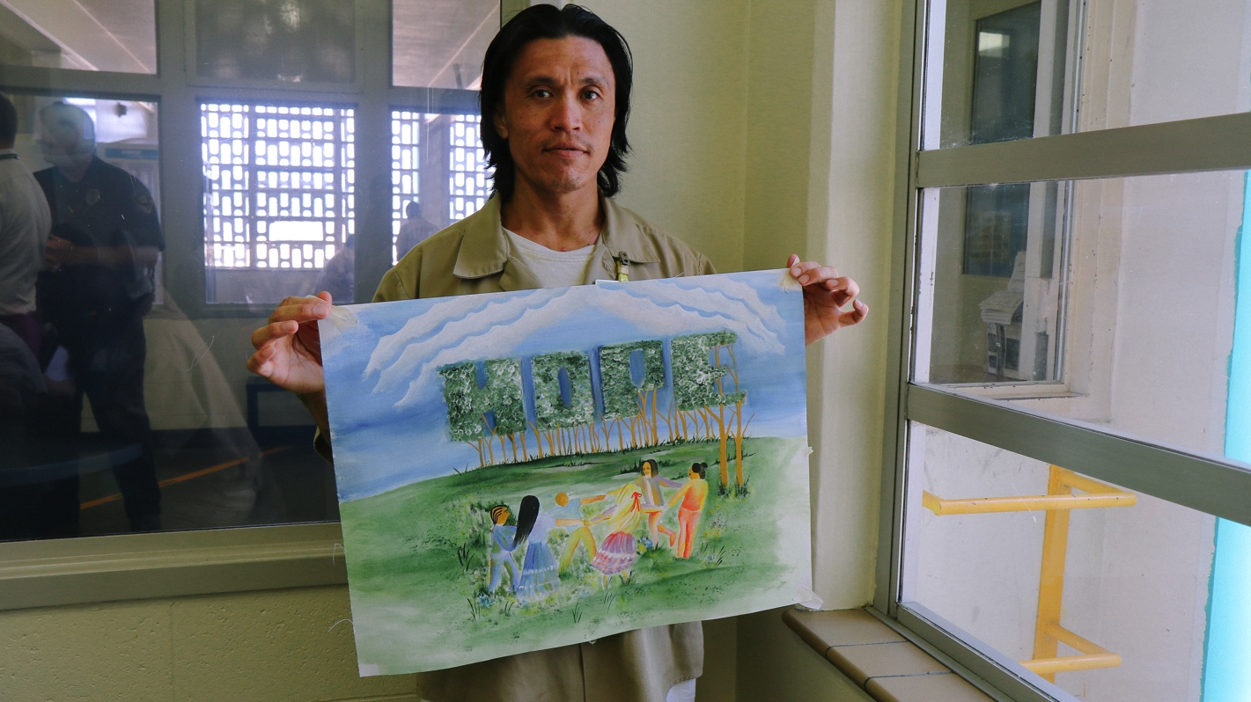
Barry Siphoy, an inmate at Washington Corrections Center in Shelton, Washington holds up a colorful painting with the word “Hope." Barry was housed in the Skill Building Unit, an example of a less-restrictive housing alternative to segregation.

ABOUT THE PROJECT
The Amplifying Voices of Inmates with Disabilities (AVID) Prison Project produced this report through a collaboration between The Arizona Center for Disability Law, Disability Law Colorado, The Advocacy Center of Louisiana, Disability Rights New York, Protection and Advocacy for People with Disabilities of South Carolina, Disability Rights Texas, Disability Rights Washington, and the National Disability Rights Network, with contributions from other protection and advocacy agencies.

ABOUT THE AUTHOR
Anna Guy is an attorney with Disability Rights Washington’s AVID Prison Project, where she focuses on both individual and systemic advocacy on behalf of inmates with disabilities. Prior to coming to Disability Rights Washington, Anna protected the rights of individuals with disabilities by serving as a voting member on the Behavioral Associates of Massachusetts, Human Rights Committee. Anna graduated from Roger Williams University School of Law (RWU) where she received recognition for her commitment to public service. While at RWU, Anna participated in a medical-legal collaborative program with the Warren Alpert Medical School of Brown University. She also represented clients as a student attorney in the RWU Criminal Defense Clinic, and held various internships and externships in which she was an advocate for marginalized populations. Prior to attending law school, Anna graduated on the Dean’s List from the University of Nevada, Las Vegas with a B.A. in Psychology.

This report, the multimedia report and associated videos, were designed and produced by Rooted in Rights.
Learn more at rootedinrights.org.

Published September 8, 2016
© 2016 Disability Rights Washington

Definitions of the terms “solitary confinement,” “isolation,” and “segregation” vary between jurisdictions and facilities. This report uses the term “segregation” to describe the general practice, described in more detail below, of isolating an inmate for 22 to 24 hours a day in a small cell.
See Am. Civil Liberties Union, The Dangerous Overuse of Solitary Confinement in the United States 2 (2014), https://www.aclu.org/sites/default/files/assets/stop_solitary_briefing_paper_updated_august_2014.pdf; Peter Scharff Smith, The Effects of Solitary Confinement on Prison Inmates: A Brief History and Review of the Literature, 34 Crime & Just. 441, 442-43 (2006).
See Chad S. Briggs et al., The Effect of Supermaximum Security Prisons on Aggregate Levels of Institutional Violence, 41 Criminology 1341, 1345 (2003).
See Sarah Baumgartel et al., The Liman Program, Yale Law School, Association of State Correctional Administrators, Time-In-Cell: The ASCA-Liman 2014 National Survey of Administrative Segregation in Prison ii (2015), https://www.law.yale.edu/system/files/documents/pdf/asca-liman_administrative_segregation_report_sep_2_2015.pdf.
In discussing inmates with mental illness, this report uses the broad definition of “individual with a mental illness” from the Protection and Advocacy for Individuals with Mental Illness (PAIMI) Act. Under this act, an “individual with a mental illness” is an individual “who has a significant mental illness or emotional impairment, as determined by a mental health professional qualified under the laws and regulations of the State….” 42 U.S.C. § 10802(4)(A). “Significant mental illness” and “emotional impairment” are not further defined in the PAIMI Act or its implementing regulations. However, courts have generally favored a broad definition of these terms. See Connecticut Office of Prot. & Advocacy for Persons with Disabilities v. Hartford Bd. of Educ., 355 F. Supp.2d 649, 655 (D. Conn. 2005), aff'd, 464 F.3d 229 (2d Cir. 2006).
See Human Rights Watch, US.: Number of Mentally Ill in Prisons Quadrupled (2006), http://www.hrw.org/news/2006/09/05/us-number-mentally-ill-prisons-quadrupled; Stuart Grassian, Psychiatric Effects of Solitary Confinement, 22 Wash. U. J.L. & Pol’y 325, 333 (2006).
See Allen J. Beck, Bureau of Justice Statistics, U.S. Dep’t of Justice, Special Report: Use of Restrictive Housing in U.S. Prisons and Jails, 2011-12 1 (2015), http://www.bjs.gov/content/pub/pdf/urhuspj1112.pdf.
See Jessica Knowles, “The Shameful Wall of Exclusion”: How Solitary Confinement for Inmates with Mental Illness Violates the Americans with Disabilities Act, 90 Wash. L. Rev. 893, 904-05 (2015) (citing several studies).
See Kenneth L. Appelbaum, MD, American Psychiatry Should Join the Call to Abolish Solitary Confinement, 43 J. Am. Acad. Psychiatry & L. Online 406, 411 (Dec. 2015), http://www.jaapl.org/content/43/4/406.
See Barack Obama, Opinions, Why we must rethink solitary confinement, Wash. Post, Jan. 25, 2016, https://www.washingtonpost.com/opinions/barack-obama-why-we-must-rethink-solitary-confinement/2016/01/25/29a361f2-c384-11e5-8965-0607e0e265ce_story.html.
This report focuses on the segregation of individuals with mental illness. However, some of the same concepts apply to people with developmental and intellectual disabilities, and people with brain injuries. Therefore, much of the analysis applied throughout this report to individuals with mental illness holds for people with other cognitive disabilities as well.
See Rebecca Vallas, Center for American Progress, Disabled Behind Bars: The Mass Incarceration of People With Disabilities in America’s Jails and Prisons 1-2 (2016), https://www.americanprogress.org/issues/criminal-justice/report/2016/07/18/141447/disabled-behind-bars/.
To fund AVID, DRW applied for cy pres funds that were the result of litigation against AT&T regarding prison phone charges. DRW, along with dozens of other organizations in Washington, was awarded funding from this cy pres pool to conduct corrections-based advocacy. DRW has since obtained additional private grant funding to expand the AVID project to encompass advocacy in specific local Washington jails as well.
While many P&As engage in advocacy relating to conditions in city jails, county jails, and immigration detention or holding facilities, this report primarily focuses on the work P&As have done in state prisons, with one example from a federal correctional facility.
The report includes examples from the following 21 states: Arizona, Colorado, Connecticut, Florida, Illinois, Indiana, Iowa, Kentucky, Maryland, Massachusetts, Montana, Nebraska, Nevada, New York, North Carolina, Ohio, Oregon, South Carolina, Tennessee, Vermont, and Washington.
See Nat’l Disability Rights Network, Our History, http://www.ndrn.org/about/26-our-history.html (last visited July 22, 2016).
See, e.g., Developmental Disabilities Assistance and Bill of Rights Act of 1975, 42 U.S.C. § 15041-15045; Protection and Advocacy for Individuals with Mental Illnesses Act, 42 U.S.C. § 10801-10851; Protection and Advocacy of Individual Rights, 29 U.S.C. § 794e.
See 42 C.F.R. § 51.42(b).
Given the exhaustion requirements of the Prison Litigation Reform Act, most inmates and advocates begin with advocacy via the prison’s internal grievance system, moving onto other forms of advocacy, particularly litigation, only after exhausting the avenues of redress available within the prison. See 42 U.S.C. § 1997e(a).
See 42 U.S.C. § 10807(a) (requiring that P&As exhaust administrative remedies where appropriate before commencing litigation).
The requirements for an agency asserting organizational standing are set forth in Hunt v. Wash. State Apple Adver. Comm’n, 432 U.S. 333, 343 (1997).
See Alison Shames et al., Vera Institute of Justice, Solitary Confinement: Common Misconceptions and Emerging Safe Alternatives 8 (2015), http://www.vera.org/sites/default/files/resources/downloads/solitary-confinement-misconceptions-safe-alternatives-report_1.pdf.
See Thomas L. Hafemeister & Jeff George, The Ninth Circle of Hell: An Eighth Amendment Analysis of Imposing Prolonged Supermax Solitary Confinement on Inmates with a Mental Illness, 90 Denv. U. L. Rev. 1, 47-48 (2012).
See American Bar Association, ABA Standards for Criminal Justice: Treatment of Prisoners 55-57, 95-99 (3d ed. 2011), http://www.americanbar.org/content/dam/aba/publications/criminal_justice_standards/Treatment_of_Prisoners.authcheckdam.pdf (recommending that inmates in segregation be provided equal access to services and mental health treatment).
Grassian, 22 Wash. U. J.L. & Pol’y at 333.
Jeffrey L. Metzner & Jamie Fellner, Solitary Confinement and Mental Illness in U.S. Prisons: A Challenge for Medical Ethics, 38 J. Am. Acad. Psychiatry & L. Online 104, 105 (2010), http://www.jaapl.org/content/38/1/104.full.
See Am. Civil Liberties Union, The Dangerous Overuse of Solitary Confinement in the United States 3 (2014), https://www.aclu.org/sites/default/files/assets/stop_solitary_briefing_paper_updated_august_2014.pdf
See Metzner & Fellner, supra note 25, at 104.
See American Bar Association, ABA Standards for Criminal Justice: Treatment of Prisoners 32 (3d ed. 2011), http://www.americanbar.org/content/dam/aba/publications/criminal_justice_standards/Treatment_of_Prisoners.authcheckdam.pdf.
See Maclyn Willigan, Solitary Watch, What Solitary Confinement Does to the Human Brain, http://solitarywatch.com/2014/08/04/what-solitary-confinement-does-to-the-human-brain/ (Aug. 2014).
Am. Civil Liberties Union, The Dangerous Overuse of Solitary Confinement in the United States 5 (2014), https://www.aclu.org/sites/default/files/assets/stop_solitary_briefing_paper_updated_august_2014.pdf.
Am. Pub. Health Ass’n, Solitary Confinement as a Public Health Issue (2013), https://www.apha.org/policies-and-advocacy/public-health-policy-statements/policy-database/2014/07/14/13/30/solitary-confinement-as-a-public-health-issue.
See Sasha Abramsky & Jamie Fellner, Human Rights Watch, Ill-Equipped: U.S. Prisons and Offenders with Mental Illness 110 (2003), http://www.hrw.org/reports/2003/usa1003/usa1003.pdf.
See, e.g., Complaint, Disability Advocates, Inc. v. N.Y. State Office of Mental Health, No. 02 CV 4002 (S.D.N.Y. May 28, 2002), http://hrw.org/reports/2003/usa1003/NYS_Disability_Advocates_Complaint.pdf; Expert Report of Kathryn Burns & Jane Haddad for Plaintiffs at 28, Bradley v. Hightower, No. 92-A-70-N (N.D. Ala. June 30, 2000), http://hrw.org/reports/2003/usa1003/Alabama_Expert_Report_Hightower.pdf.
The Eighth Amendment reads: “Excessive bail shall not be required, nor excessive fines imposed, nor cruel and unusual punishments inflicted.” U.S. Const. amend. VIII.
See Hutto v. Finney, 437 U.S. 678, 685 (1978).
Farmer v. Brennan, 511 U.S. 825, 836 (1994).
Id.
See Ruiz v. Johnson, 37 F. Supp.2d 855, 887 (S.D. Tex. 1999), rev'd and remanded sub nom. Ruiz v. United States, 243 F.3d 941 (5th Cir. 2001).
See Helling v. McKinney, 509 U.S. 25, 35 (1993).
Farmer, 511 U.S. at 837.
Id. at 842.
Estelle v. Gamble, 429 U.S. 97, 103 (1976).
See id. at 104-05.
Madrid v. Gomez, 889 F. Supp. 1146, 1265 (N.D. Cal. 1995).
Id. at 1280.
Ruiz, 37 F. Supp.2d at 907.
Id. at 915.
Jones’ El v. Berge, 164 F. Supp.2d 1096, 1122, 1124 (W.D. Wis. 2001).
The protections of the Rehab Act are substantially the same as those afforded under Title II of the ADA in relation to inmates. Bragdon v. Abbott, 524 U.S. 624, 632 (1998); 42 U.S.C. § 12201(a).
For more information about the ADA and prison, see Rachael Seevers, Disability Rights Washington, Amplifying Voices of Inmates with Disabilities Prison Project, Making Hard Time Harder: Programmatic Accommodations for Inmates with Disabilities Under the Americans with Disabilities Act (2016), http://www.avidprisonproject.org/. See also Margo Schlanger, Memorandum Re: The ADA/Rehab Act and solitary confinement (2015), https://www.law.umich.edu/facultyhome/margoschlanger/Documents/Schlanger_ADA-seg_memo_FINAL_12-09-2015.pdf.
Disability Advocates, Inc., now Disability Rights New York, was a regional protection and advocacy office with the New York P&A system.
Disability Law Colorado is not using federal grant money to fund this litigation because it involves a federal agency.
Many of the settlement terms were incorporated into New York’s “SHU Exclusion Law” which passed both houses and was signed into law in July 2007. The SHU Exclusion provisions went into effect in July 2011, following the anticipated sunset of the lawsuit’s settlement agreement. (See discussion above under Non-Litigation).

